2 – WORK IN THE COMPANY

2.2 – PICTURES OF KENT RIDGE DIGITAL LABS

The pictures presented here shows the two locations of Kent Ridge Digital Labs that I was attached to from 6th July 1998 to 16th October 1998.

2.2.1 - Science Park II

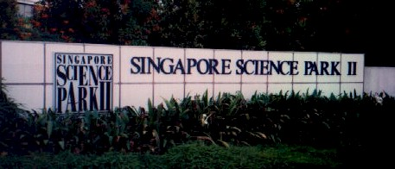

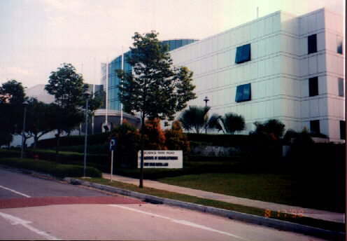

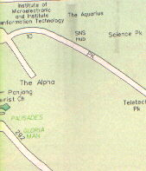

Attachment to:

Kent Ridge Digital Labs
11, Science Park Road.
Singapore Science Park II,
Singapore 117685.
(6th July 1998 – 2nd September 1998)

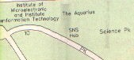
This is my workplace under the department known as Knowledge Lab. The room I am in is the Inquisitive Lab (32-10), located on the 2nd floor of the old KRDL.

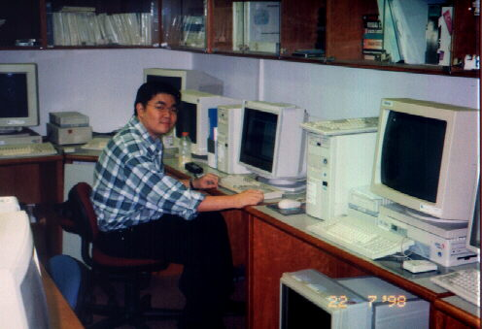

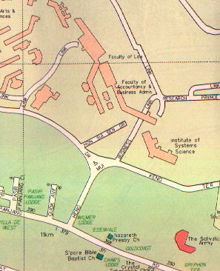
2.2.2 – Heng Mui Keng Terrace

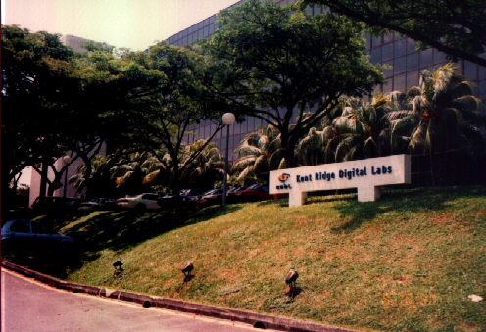

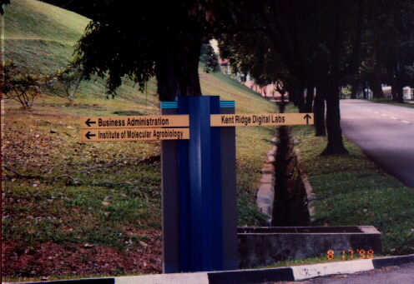

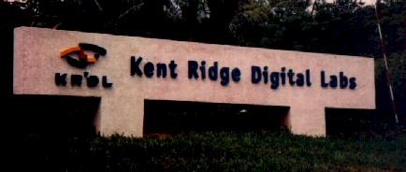
Attachment to:

Kent Ridge Digital Labs
21, Heng Mui Keng Terrace,
Singapore 119613.
(3rd September 1998 – 16th October 1998)

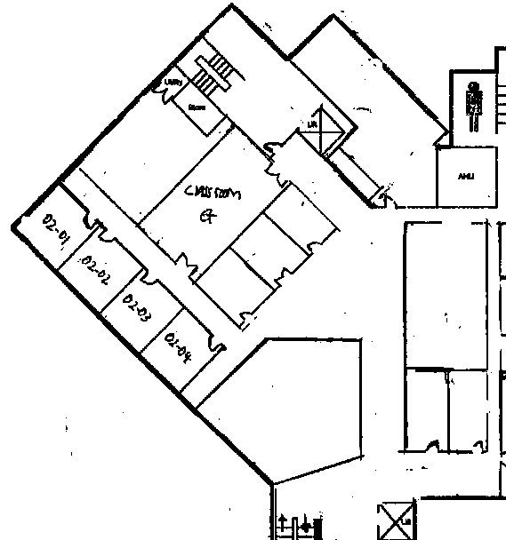
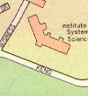
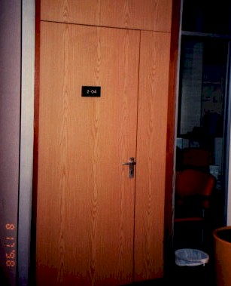
This is Room 02-04, my workplace for the Building in Heng Mui Keng Terrace.

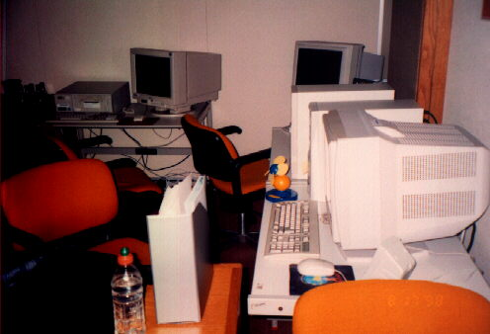

The other picture on the right shows my work area, which is just right next to the door.

